Unit 4 Study Guide

- Why were Spanish missions built? To protect Spanish Land Claim
- Put in chronological order: (1st -b), (2nd -a), (3rd -c)
  - East Texas missions are moved to San Antonio
  - Establishment of 1st mission at Corpus Christi de la Ysleta
  - La Bahia Mission moved from Guadalupe River to Goliad
- When was the founding of San Antonio? 1718
- How did the American Indian tribes view the Spanish missions? American Indians viewed the Spanish Missions with Suspicion

- List three important facts about Jose de Escandon:
  - military commander & governor of Laredo
  - sent settlers to lands between the Rio Grande and Nueces
  - led Spanish Expansion efforts into South Texas

- What is a vaquero? Cowboy
- List four important facts about Francisco Hidalgo:
  - in charge of Mission in East Tejas
  - lived in mission San Antonio de Valero
  - resigned & preached among the Apaches
  - died in 1726 (67 years old)

- List four important facts about Fray Damian Massanet:
  - was on two expeditions into East Texas
  - kept detailed records
  - established a mission among the Tejas Indians
  - kept detailed information on American Indian culture
    - housing, clothing, food, and customs
- What two things make a settlement a mission? Church and Indian quarters

- List three ways Early Spanish Settlers adapted to their environment:
  - planted crops
  - used timber (wood) and Stone
  - used animal skins
- What did Spanish Settlers use for Food, Shelter, and Clothing?
  - Food- Planted crops and cattle
  - Shelter- Used logs and stone
  - Clothing- Animal Skins
- 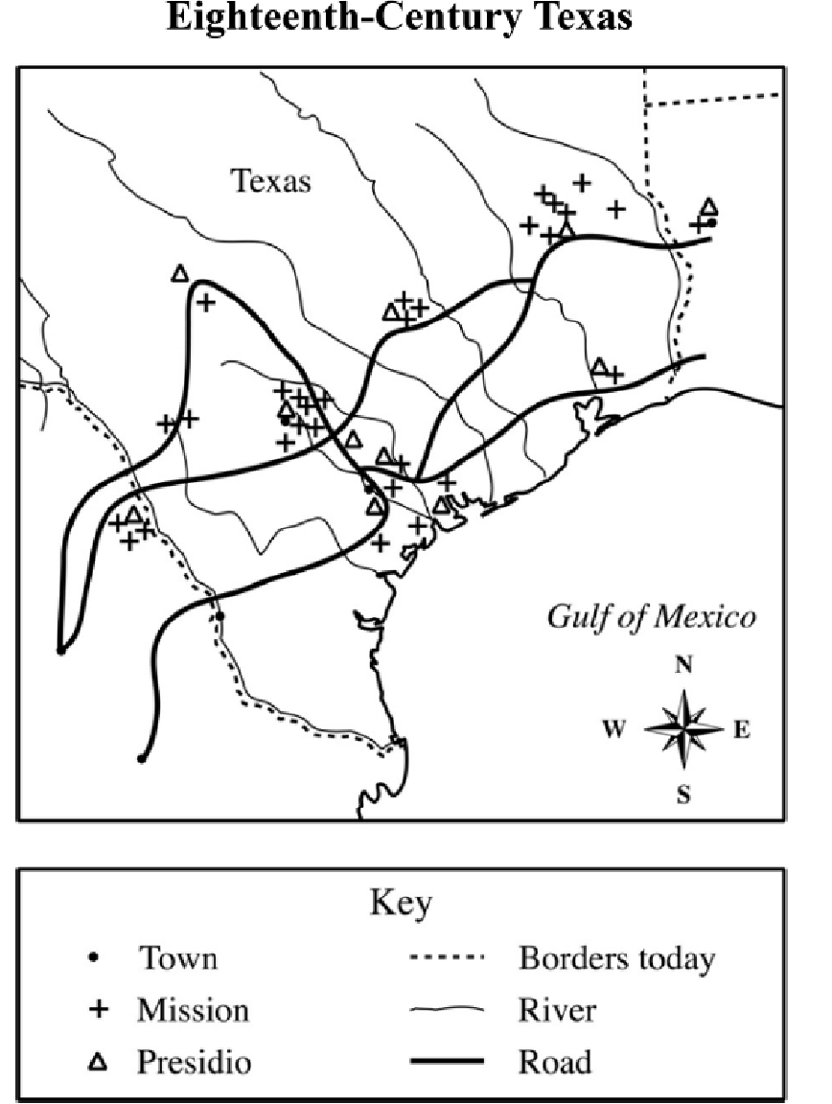
- Which physical geographic feature influenced where the missions and presidios were built in Texas? Mission were built close to rivers

- How many towns were added and where were they located? 4

