Read Chapter 8 and 9

Review
http://quizlet.com/56404271/stephen-f-austin-and-the-empresarios-flash-cards/
Stephen F. Austin and the Empresarios33 terms
Take notes for quiz
Read Terms/ Flash Cards
Take Quiz must get at least an 80%

Watch video- Texas Independence 7:30 minutes
http://www.youtube.com/watch?v=cZez0OotwC8
Take 15 Notes- Be sure they are complete thoughts!

Many Causes of the Texas Revolution
http://www.austincc.edu/lpatrick/his1693/causes.html
- What are the seven reasons the website gives for the Texas Revolution
- What was the United States “divine mission” for North America
- What happened in the United States in 1819
- What was the United States first Constitution called? It lasted from 1776 to 1788
- List four problems the United States encountered during its first twelve years.
- What was the relationship between Texas and Mexico from 1821 to 1835?
- Racial prejudice was running ramped in Texas as both Mexicans and Anglo Texans felt they were superior, List three racial slurs each exchanged.
- List the various cultural differences between Anglo Texans and Mexican Texans.
- In October 1835, the centralists and Santa Anna enacted what three changes that angered many Texans?
- Many Texans favored slavery, what do you think the Mexican government should have done about this issue?
- How did the isolation of Texas contribute to the Texas Revolution?

Colonization to Texas Independence30 terms
http://quizlet.com/_cxdh
Take notes for quiz
Read Terms/ Flash Cards
Take Quiz must get at least an 80%

Texas Independence PowerPoint
http://mrkash.com/activities/texasrevolution.ppt#1
Take 29 specified notes

http://www.powershow.com/view/147f9b-MTdmM/Texas_Independence_1836_powerpoint_ppt_presentation
Take 20 notes- be sure they are complete thoughts

Re-teach the Principles of the Constitution
- Write these definitions!

- Republicanism – a belief that government should be based on the consent of the people; people exercise their power by voting for political representatives

- Limited Government - a framework for government that limits the power of government by stating what the government can and cannot do

- Individual Rights – personal liberties and protections from too much government guaranteed to U.S. citizens by the Bill of Rights

- Checks and Balances – the ability of each branch of government to exercise checks, or controls, over the other branches

- Separation of Powers – the division of basic government roles into branches to prevent one branch from becoming too powerful

- Federalism – a system of government in which power is shared among the central (or federal) government and the states (Texas would not be able to have a federal government but would become a part of one if they joined the United States.)

- Popular Sovereignty – a government in which the people hold the power through participation, most importantly the voting process

Jeopardy- Texas Independence

http://www.birdville.k12.tx.us/instech/Tx%20History%20Shines%20with%20Music/Ballad%20of%20the%20Alamo/Alamo%20Jeopardy/Texas%20Alamo.ppt#1

Name _____________________________ Period ___________ Date _______________

Unit 6 Study Guide

- The Revolution Era included what battles?
- Sequence the following events:
  - Fall of the Alamo
  - Battle of San Jacinto
  - Goliad Massacre
  - Battle of Gonzales

- When was Texas annexed by the United States?
- What law was passed to prevent Texas from declaring Independence?
- Who was the primary author of the Texas Declaration of Independence?

- Where was the Battle of Coleto Creek, and what happened to James Fannin?

- George Washington: American Revolution:: ________________: Texas Revolution

- Who was the commander of the Alamo and what did the Mexican army do during the siege of the Alamo?
- Which battle helped to prove to Texans that the Mexican army could be defeated and independence gained?

- What place became a battleground because it defended Anglo settlements and delayed the Mexican army?

- The Republic of Texas and the Texas Constitution created a controversy over what issue?

- Who was the leader during the Texas annexation to the United States?

- What famous group helped to protect Texans from American Indians?

- 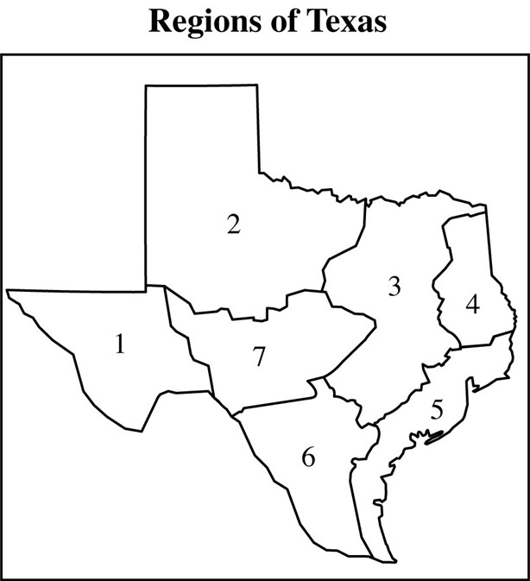 Which two regions did most of the battles of the Texas Revolution take place?

- What single factor was the reason why most battles took place in these regions?

- 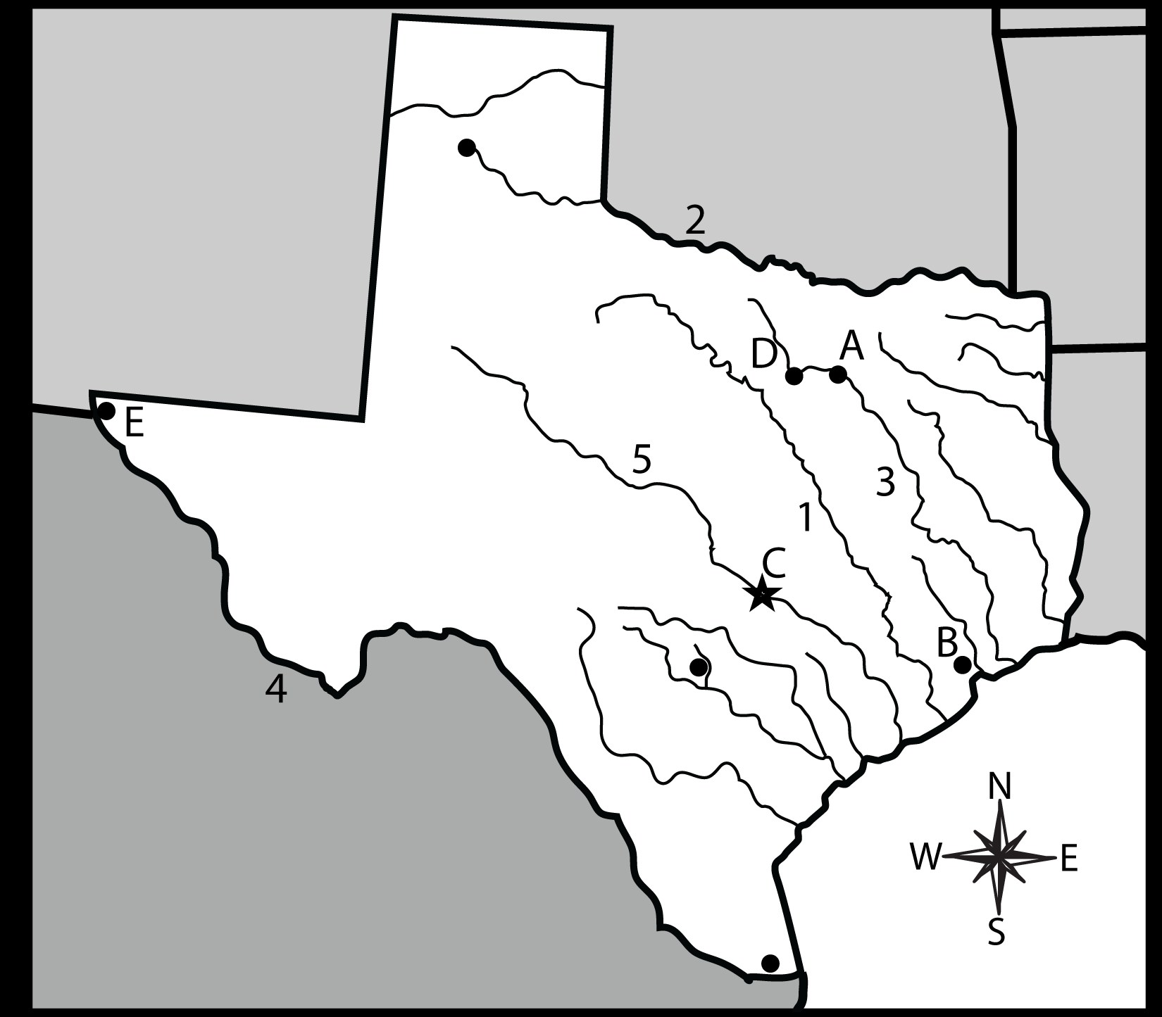

Identify all of the locations on the map that have either letters or numbers.

- 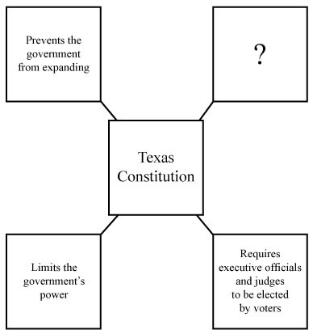Which of the Seven Principles best finishes the chart?
- Which of the Seven Principles best represents the democratic principle of the election of government officials?

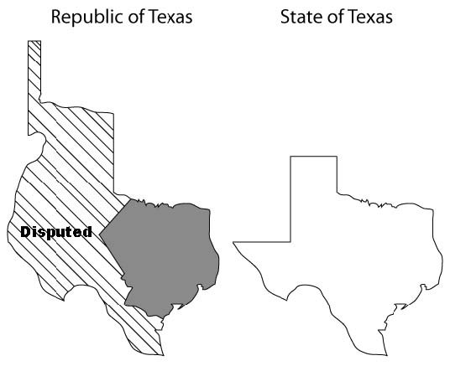

- During his time as the president of the Republic of Texas, Mirabeau Lamar made several controversial decisions including this one that was intended to set claim to a lucrative trade route to ____________. After sending troops and merchants to the area, his expedition was captured and taken to Mexico City and imprisoned. After months of negotiation, most soldiers were released; However, this was yet another in a series of conflicts with Mexico that eventually led to ____________.

Santa Fe . . . annexation to the United States

- Who is the person indicated by these three situations:
  - forced removal of the Cherokee to Oklahoma
  - Council House fight
  - death of Chief Bowles

Use the passage and your knowledge of social studies to answer the following question. Stephen F. Austin and the Road to the Texas Revolution have you ever heard of the independent nation of Fredonia? Did you know it was a part of what is now Texas? On December 16, 1826, a small group of men in Nacogdoches set up Fredonia. They were led by Benjamin Edwards. These men were able to organize a new government, but there were those who did not support the Fredonian Republic. Stephen F. Austin was one of them. In January of the next year, about 60 Mexicans tried to capture Nacogdoches. The Fredonians joined with Native Americans and soundly defeated the 60 invaders. Soon Stephen F. Austin and other Mexican troops arrived but Edwards had left his new government and gone to Louisiana to safety. This was the end of the Fredonian Republic. The episode, though, was one of the first efforts by any group in Texas to gain independence from Mexico. Over time, tensions grew between the government in Mexico and the Texans. Austin truly believed that differences and tensions could be resolved without drastic action. He called for a limited form of government and some reforms such as religious freedom. Despite his efforts, he was not successful in calming the growing tide toward war. Finally, Austin went to Mexico City in 1833 with a petition. The unsuccessful petition asked for a separate state government for Texas. Austin wrote a letter home recommend-ing that people go ahead with starting a Texas state on their own without waiting for permission from Mexico. Unluckily, the letter was found by the Mexican government. He was arrested and made a prisoner without a trial. His prison term lasted a year before he was allowed to return to Texas. In the end, Austin himself took command of a military troop in the Texas Revolution, even though he had tried so hard to avoid it.

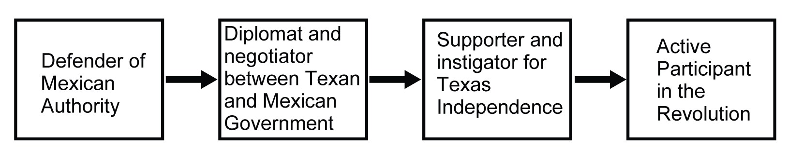
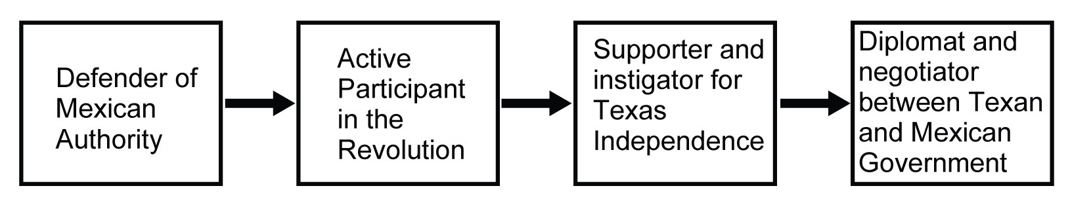
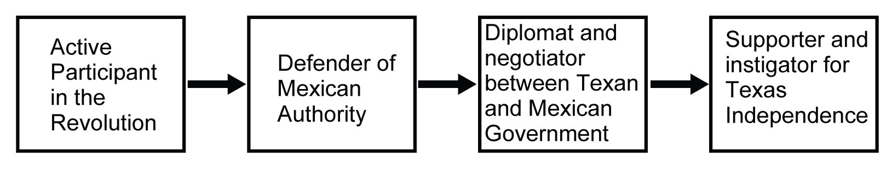
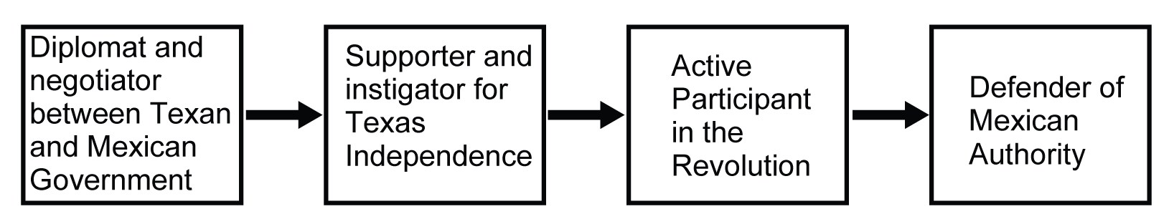

- Which flowchart demonstrates Austin’s changing point of view toward independence from Mexico?

- List three important facts concerning Juan Seguin and the Texas Revolution

- What three ships helped bring trade and wealth to the river cities of the Republic of Texas?

- How were ships during the 1830s powered?

- What are the physical features of the area around the Battle of Coleto?

- Finish the three effects of the Turtle Bayou Resolution:
  - What happened to Colonel Jose Mexia’s army

  - Texas prisoners of the Mexican government

  - John Bradburn

- Chief Bowles and Jose Navarro: One supported Sam Houston and one criticized his leadership

- Why did Sam Houston oppose the building of a Texas Navy?

