Unit 6 Study Guide
Revolution and Republic Era

- The siege of the Alamo took place during what era?

- Put the following in sequential order:

  - Fall of the Alamo
  - Battle of San Jacinto
  - Goliad Massacre
  - Battle of Gonzales
- Texas was annexed by the United States in what year?

- What law was passed in 1830 to stop U.S. immigration to Texas?

- Who was the primary author of the Texas Declaration of Independence?

- What happened to James Fannin after the Battle of Coleto Creek?

- George Washington : American Revolution

______________: Texas Revolution

- What did William B. Travis write in his Letter from the Alamo, February 24, 1836?

- This battle proved to Texans that the Mexican army could be defeated and independence achieved.

- To defend Anglo settlements and delay the Mexican army was the main reason for this battle of the Texas revolution.

- Freedom for most Texans to live and work as they pleased, though slavery was permitted in the Republic of Texas and the _______________________ ________________________.

- The Texas annexation to the United States was led by ________________ ______________.

- They protected Texans from American Indians.

- Most of the battles of the Texas Revolution were fought in which areas of the map? (Hint there are two.)

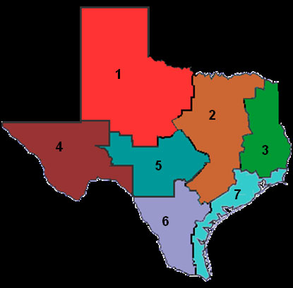

- Which factor was most influential in determining the location of many battles during the Texas Revolution?

- Be able to show on a map where the San Jacinto Monument is located.

- Which principle of government is missing?

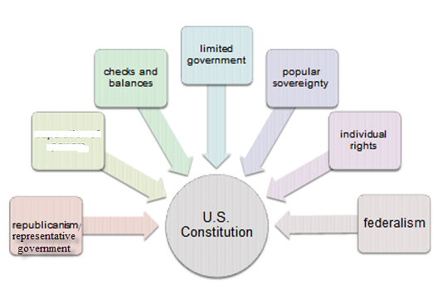
- Which of the seven principles of government is represented in the following sentence: It uses elections to determine many government officials.

- The attack on Santa Fe led the United States to __________________ Texas.

- His administration led to the forced removal of the Cherokee to Oklahoma, the Council House fight, and the death of Chief Bowles.

- Which leader of Texas am I:

  - Defender of Mexican authority
  - Diplomat and negotiator between Texan and Mexican governments
  - Supporter and instigator for Texas independence
  - Active participant in the revolution

- Who am I:
- I was sent as a messenger to warn Sam Houston about the situation in San Antonio.
- I stayed with Houston and served in the final battle ending the revolution.
- I served as the only Tejano in the Senate of the Republic.

- What am I?
  - They contributed to security of the new nation's southeastern border from attacks by navies from other countries.
  - They contributed to the debt of the new nation.
  - They could serve as a blockade of the Mexican coast in protection of Texas.

- What was the source of power for the Texan Navy ships?

- During this battle Fannin’s army of Texans camped in an open land area that allowed the men to be surrounded with no protection from the Mexican army.

- These are all parts of what Resolution:

  - Colonel José Mexia and his army returned to Mexico.
  - Texas prisoners of the Mexican government were freed.
  - John Bradburn was relieved of his command.

- Which was a supporter and which was an opponent of Sam Houston?
  - Chief Bowles
  - José Navarro

- The Texas Navy was a drain on Texas finances and mostly ineffective and was opposed by ________________ __________________.

